PrerequisitesTier 1: Absolutely Essential (Non-Negotiable)
This is the core knowledge the syllabus assumes you already have.
- Modern JavaScript (ES6+): The entire syllabus is built on Node.js, which is a JavaScript runtime. You must be comfortable with:
  - Core Fundamentals: Variables (let, const), Data Types, Operators, Loops (for, while), and Conditionals (if/else, switch).
  - Functions: How to declare functions (standard and arrow functions () => {}). Understanding "callbacks" is a huge plus.
  - Data Structures:
    - Objects: Creating object literals, accessing properties, and understanding this (though its behavior in Node.js is simpler than in browser JS).
    - Arrays: Creating arrays and using common methods like .map(), .filter(), .find(), and .forEach().
  - Asynchronous JavaScript (Crucial): This is the single most important prerequisite. Backend development is full of asynchronous operations (like database queries and API calls). You must understand:
    - Promises: How to write and consume promises (.then(), .catch(), .finally()).
    - async/await: This is the modern standard used in almost all backend code. You must know how to use async functions and the await keyword to handle promises.
  - ES6+ Features:
    - Modules: Understanding how to import/export (ESM) or require/module.exports (CommonJS). The syllabus will heavily use this for file organization.
    - Destructuring: Easily pulling properties from objects and arrays.
    - Spread/Rest Operators: (...).

Tier 2: Core Web Concepts
You need to understand the "environment" your backend will operate in.
- The Client-Server Model: You must understand the basic architecture of the web.
  - What is a Client (e.g., browser, mobile app)?
  - What is a Server (the code you will be writing)?
  - What is a Request and a Response?
- 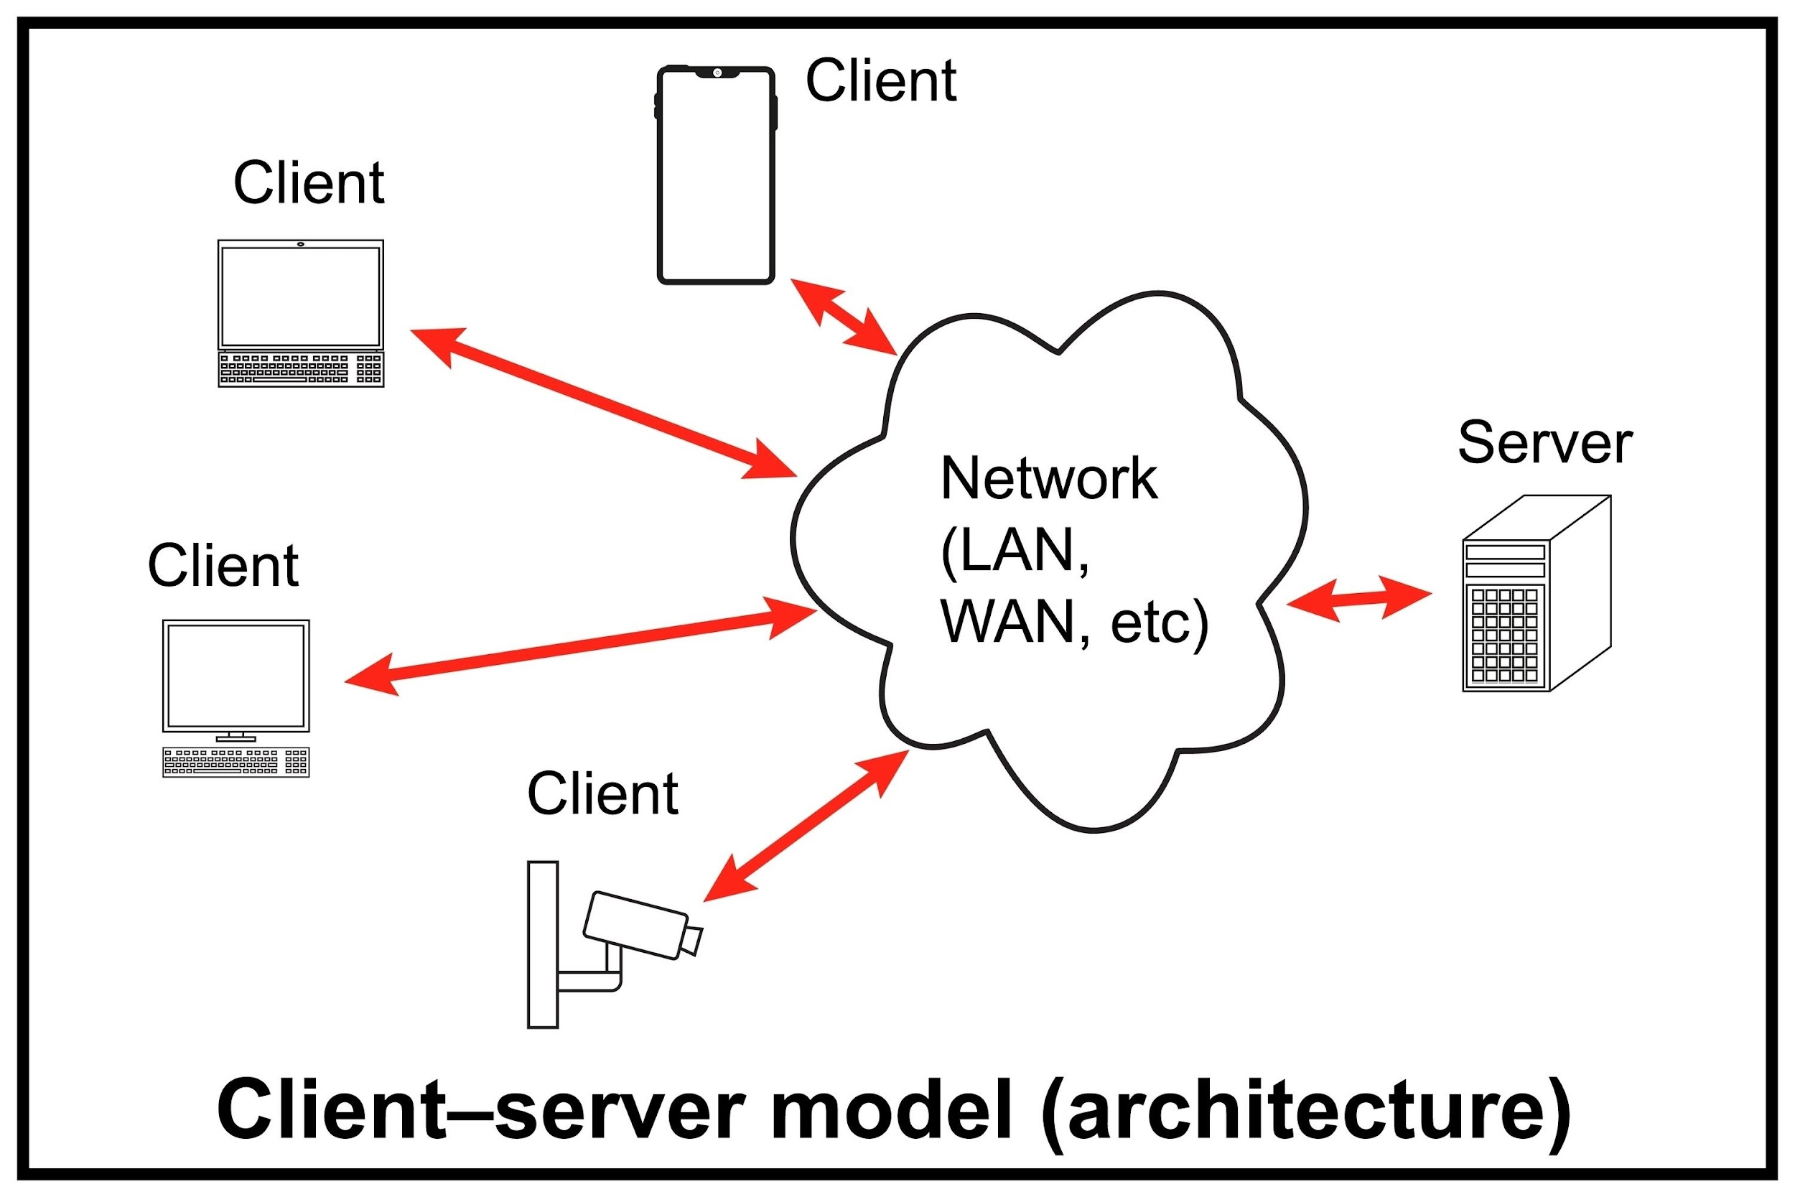
- Shutterstock
- HTTP Basics: The syllabus mentions REST APIs, status codes, and request methods. You should know:
  - What the common methods are for: GET, POST, PUT, DELETE, PATCH.
  - What common status codes mean (e.g., 200 OK, 404 Not Found, 500 Internal Server Error).
- Data Formats (JSON): JSON (JavaScript Object Notation) is the language of modern APIs. You must know what JSON is and how to read and write it.
- Basic HTML/CSS: The syllabus includes EJS (a template engine), which mixes HTML with backend data. You don't need to be a frontend developer, but you must know basic HTML tags (<div>, <form>, <p>, etc.) to understand what you are sending to the browser.

Tier 3: Essential Developer Tools
These are the tools you'll use every day.
- Using the Command Line (Terminal/CLI): You must be comfortable navigating your computer without a GUI. You should know how to:
  - Navigate folders (cd).
  - List files (ls or dir).
  - Create folders (mkdir).
  - Run basic commands.
- NPM (Node Package Manager): Since the syllabus uses Node.js, you must know what npm is and how to use it to:
  - Initialize a project (npm init).
  - Install packages (npm install <package_name>).
  - Understand the purpose of package.json.
- Basic Git & GitHub: The syllabus mentions Git configuration. You should know the basic workflow:
  - git init
  - git add
  - git commit
  - git push

Backend Syllabus

Module 1: The Foundation - Node.js & Basic Servers
This module covers the absolute basics: what Node.js is, how to run it, and how to create a server without any frameworks.
- 1. Starting with Node.js - The Beginning 🏁
  - Introduction to Node.js and Getting Our Tools - Node.js LTS, Postman, Editor
  - Setting up the Tools for our Environments
  - Running script with nodejs - “Namaste Duniya”
  - NPM Basics | Installing Packages.
  - Creating and Managing package.json.
- 2. Creating Server - Writing Our First Server 📱
  - What is Server and how it works?
  - Setting Up Our First Node.js Server using HTTP
  - Serving A Response to the Browser and Understanding Responses.
  - Routing in HTTP Servers.
  - Understanding Status Code - 1XX , 2XX , 3XX ,404 - Not Found , 200 - success , 500 - Internal Server error , 422 - Invalid Input , 403 - the client does not have access rights to the content , etc.
  - Installing Nodemon for Automatic Server Restarts.

Module 2: The Framework - Express.js Core Concepts
This module introduces the Express framework, its underlying architecture (MVC), and its most critical concepts: middleware and error handling.
- 3. Some talk on Different Architectures 🏯
  - Different Architectures in backend like MVC and SOA.
  - Understanding MVC Architecture Model , View ,Control.
  - MVC in the context of REST APIs.
- 4. Web Framework - Express.js 🚀
  - what is Express.js and why to use it.
  - Setting Up Express Server .
  - Returning Response from the server.
  - Using Query Parameters and URL Parameters.
  - HTTP Request - Some Important part of requests , Different Types of Requests - Get , Post , PUT , Patch , Delete.
- 6. Middleware in Express.js (one of my favorite) 🐵
  - Understanding the middleware in express.
  - Implementing middleware with express.
  - Different types of middleware : builtIn middleware , third-party middleware ,custom middleware .
  - Different level of middleware : Application-Level , Router-Level .
- 16. Error handling in express 🛑
  - Basic Error Handling in Express next() .
  - Catching Specific Errorstry &catch .
  - Creating Util Class for Error Handling.

Module 3: Server-Side Rendering & Static Files
This module focuses on the "V" in MVC: how to serve dynamic HTML pages using a template engine and how to serve static assets like CSS and images.
- 5. Template Engine - EJS 🚜
  - What is Template Engine and What is the use of Template Engine.
  - Template Engine Option - Handlebars , EJS , Pug , jade but We’ll use EJS .
  - Setting Up Template Engine - Installed EJS template engine.
  - Rendering Our First Page using EJS and Some important syntax - <%= %> , <% %> , <%- %>.
  - Loop statement, Conditional statement and Locals in views - EJS.
  - Accessing the Static Files Inside EJS file.
  - Includes concept from section 4: Serving Static Files with express.static()
- 7. Handling file with Express 📁
  - Understand Multer and its usecase?
  - Uploading file with multer.
  - Understanding Memory and Disk Storage.
  - Accessing uploaded file req.file.
  - Working with express.static.
  - Using Cloudinary or Imagekit for Real-time media processing APIs and Digital Asset Management.

Module 4: Databases - From Basics to Optimization (MongoDB)
This is a comprehensive module on the database. It starts with the basics of MongoDB and Mongoose and moves directly into advanced optimization techniques.
- 8. Beginning of Database Basics ( Bohot km theory ) 🗄️
  - Relational and non-relational Databases : mongodb & mysql .
  - What is MongoDB? Why Use It?
  - Installing Compass and Understand how to access DB using terminal.
  - Setting Up MongoDB Locally and in the Cloud.
  - Understanding Datatypes Collections and Documents.
  - Connecting MongoDB to Node.js with Mongoose .
  - Database Relations - One to One , One to Many OR Many to One , Many to Many , Polymorphic .
  - Handling Relationships with Mongoose (populate).
- 10. Database Optimization for Fast response 🧘🏻
  - Indexing for Performance with MongoDB :- Single-Field Indexes , Compound Indexes , Text Indexes ,Wildcard Indexes.
  - Best practice with Indexing explain().
  - Learning MongoDB Aggregation.
  - Comparison Operators - [$eq , $ne , $lt , $gt , $lte , $gte , $in , $nin]
  - Logical Operators - [$not , $and , $or and $nor]
  - Array[$pop, $pull, $push and $addToSet]
  - Stages in Aggregation pipeline :- $match , $group ,$project ,$sort ,$lookup.
  - Creating Database on Local and Atlas
  - Creating parallel pipeline with $facet .
  - Learning MongoDB Operators.
  - Understanding Different types of Operators :- Comparison ,Regex ,Update ,Aggregation.

Module 5: Building the REST API
With Express and Databases covered, this module combines them to build a full REST API, including validation and security best practices.
- 9. API Development(REST) ⛓
  - What is a REST API?
  - Versioning in RESTful APIs - /v1/
  - Using Postman for API Testing and developing - Send Requests , Save Collections , Write Tests .
  - Understanding and Working With Status code , 2xx (Success) , 4xx (Client Errors) , 5xx (Server Errors) .
  - Validating API Inputs Using libraries like express-validator or Sanitization .
  - Security Handling - Rate Limiting with express-rate-limit ,XSS Attack , CSRF Attack , DOS Attack.
  - Includes middleware concepts from section 6: Handeling Errors and Security with middleware : Error-Handling , Helmet , CORS.

Module 6: Authentication & Authorization
This module is dedicated to the critical feature of securing the API and managing user access.
- 13. Authentication and Authorization 🪪
  - Difference Between Authentication & Authorization
  - Working with Passwords and Authentication - Cookie Authentication , OAuth Authentication
  - Understanding Session and Token Authentication.
  - Implementing JWT Authentication :- jsonwebtoken JWT_SECRET.
  - Securing user password with bcrypt hashing salt.
  - Role-Based Access Control (RBAC).
  - Authenticating user with Express middleware .
  - Understanding Passport.js and its usecase?
  - Glancing through and Installing Passport.js
  - Setting up Passport.js - passport-local, local-strategy , google-OAuth
  - express-sessions and using passport for authentication.

Module 7: Advanced Features & Performance
These modules cover topics that build on top of a functional application, adding real-time capabilities and performance optimization.
- 14. Working Real time communication : WebSockets and socket.io 💬
  - Understanding WebSockets protocol for realtime applications?
  - Learning handshake ,Persistent connection ,Bidirectional communication ,HTTP polling .
  - Understanding difference between WebSocket Vs Socket.io.
  - Working with socket.io for realtime applications.
  - Understanding usage ofRooms in Socket.io.
  - Understanding Middleware in Socket.io.
- 15. Working With Caching - Local and Redis 🍄
  - What is Caching and How to cache data locally?
  - What is Redis?
  - Why Use Redis for Caching?
  - Implementing Redis Caching in Node.js.
  - Advanced Redis Features TTL ,Complex Data Structures , Pub/Sub.

Module 8: Production & Maintenance
The final module covers "real-world" practices: making your code maintainable, logging issues, and testing.
- 12. Production Wala Project Structure and Configuration 🗼
  - Understanding the Basic Structure of application.
  - Learning File Naming Conventions, Git Configuration,
  - Understanding Important Folders :- src/ ,config/ ,routes/ ,utils/ .
  - Role of package.json , ENV and .gitignore .
  - Production Environment - PM2 , Error & Response Handling Configuration , CORS Configuration , async-handler.js.
  - Using and Configuring ESLint and Prettier for code formatting.
  - Testing APIs using Postman.
- 11. Logging Backend : Express.js
  - Why is Logging Important?
  - Setting Up Logging with Libraries winstone ,Pino ,Morgan .
  - Different mode of morgan ,dev ,short ,tiny .
  - Error Handling and Logging.
- 17. Testing Tools 🛠️
  - Understanding Unit-Testing With Jest.
  - Cross Browser Testing and Why Is It Performed?
  - What Is Web Testing? and How to Test a Website.

